Section 3: Thorax and Abdomen

Card ID: 3.1
Image file: L1344_760076
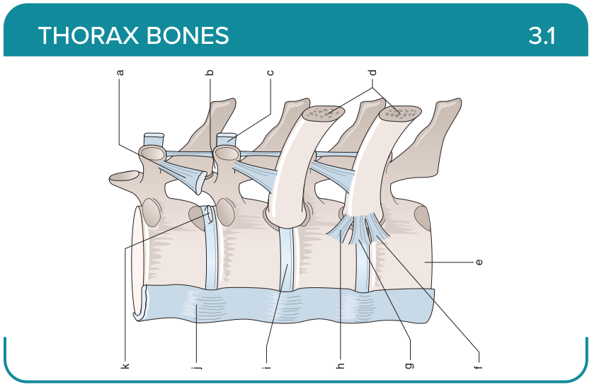
Title: Thoracic Vertebrae (Lateral View)
Activity Interaction: Drag and drop
Back-of-Card Content:
a. Superior costotransverse ligament
b. Costotransverse ligament (not shown)
c. Lateral costotransverse ligament
d. Ribs
e. Vertebral body
f. Radiate ligament (inferior band)
g. Radiate ligament (intermediate band)
h. Radiate ligament (superior band)
i. Intervertebral disc
j. Anterior longitudinal ligament
k. Intra-articular ligament

Card ID: 3.2
Image file: L1344_760077
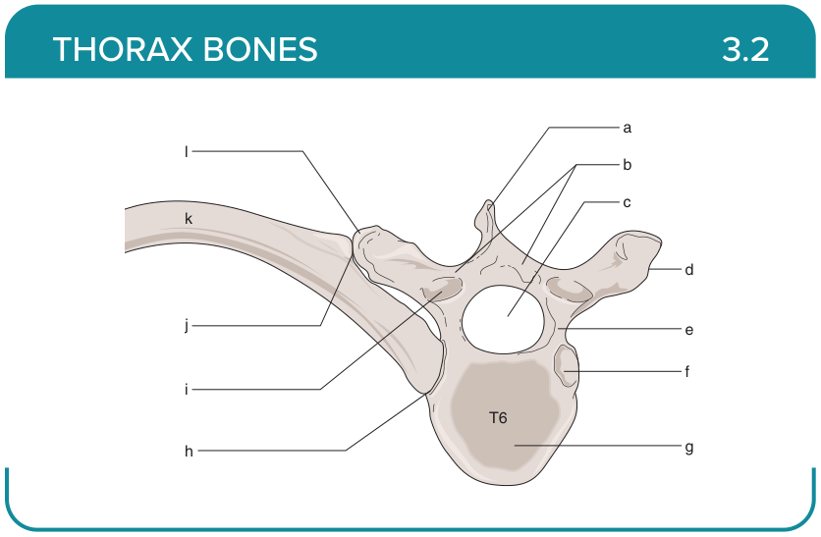
Title: Thoracic Vertebrae (Superior View)
Activity Interaction: Drag and drop
Back-of-Card Content:
a. Spinous process
b. Laminae
c. Vertebral canal
d. Costal facet
e. Pedicle
f. Superior costal facet
g. Body
h. Costovertebral joint
i. Superior articular facet
j. Costotransverse joint
k. Sixth rib
l. Transverse process

Card ID: 3.3
Image file: L1344_760078
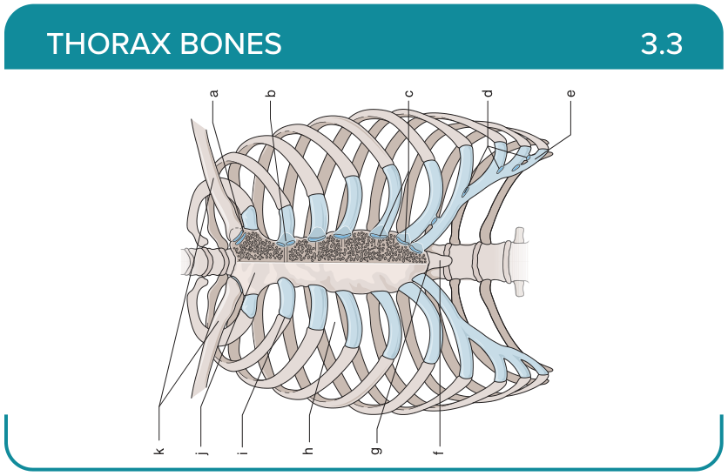
Title: Rib Cage (Anterior View)
Activity Interaction: Drag and drop
Back-of-Card Content:
a. Sternoclavicular joint
b. Second chondrosternal joint
c. Chondrosternal joints
d. Interchondral joints
e. Costal cartilage
f. Xiphoid process
g. Xiphisternal joint
h. Intercostal space
i. Costochondral joint
j. Sternum
k. Clavicles

Card ID: 3.4
Image file: L1344_760079
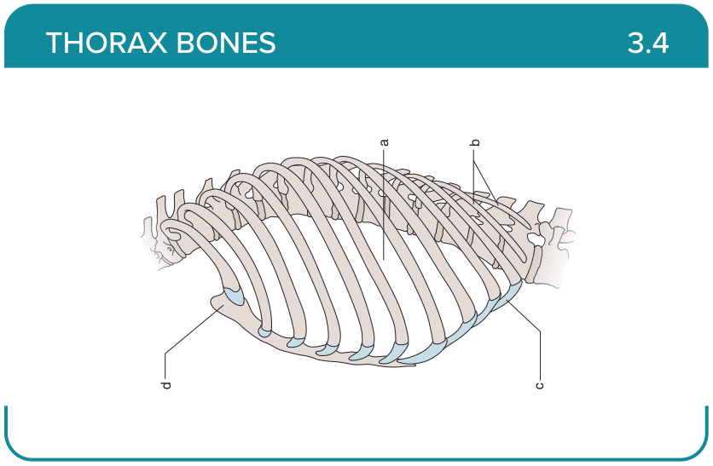
Title: Rib Cage (Lateral View)
Activity Interaction: Drag and drop
Back-of-Card Content:
a. Intercostal space
b. Floating ribs
c. Costal cartilage
d. Sternum

Card ID: 3.5
Image file: L1344_760080
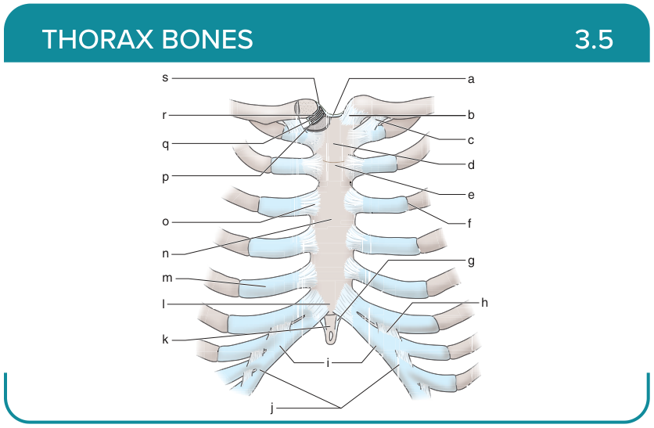
Title: Sternum and Ribs
Activity Interaction: Drag and drop
Back-of-Card Content:
a. Interclavicular ligament
b. Anterior sternoclavicular ligament
c. Costoclavicular ligament
d. Manubrium
e. Manubriosternal joint
f. Costochondral articulation
g. Costoxiphoid ligament
h. Interchondral ligament (interarticular)
i. Costal cartilage
j. Interchondral joint
k. Xiphoid process
l. Xiphisternal joint
m. Costal cartilage
n. Body
o. Costosternal ligament
p. Inferior joint cavity
q. Articular disc
r. Superior joint cavity
s. Superior sternoclavicular ligament

Card ID: 3.6
Image file: L1344_760081
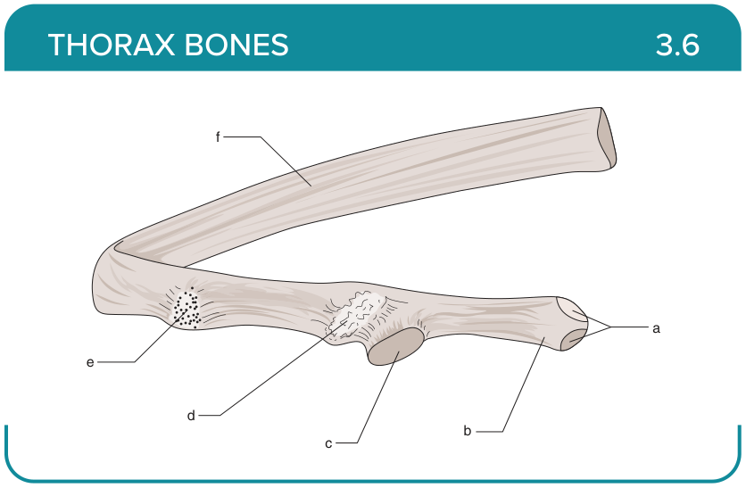
Title: Rib (Medial View)
Activity Interaction: Drag and drop
Back-of-Card Content:
a. Superior and inferior facets on the head
b. Neck
c. Tubercular facet
d. Tubercle
e. Angle
f. Shaft

Card ID: 3.7
Image file: L1344_760082
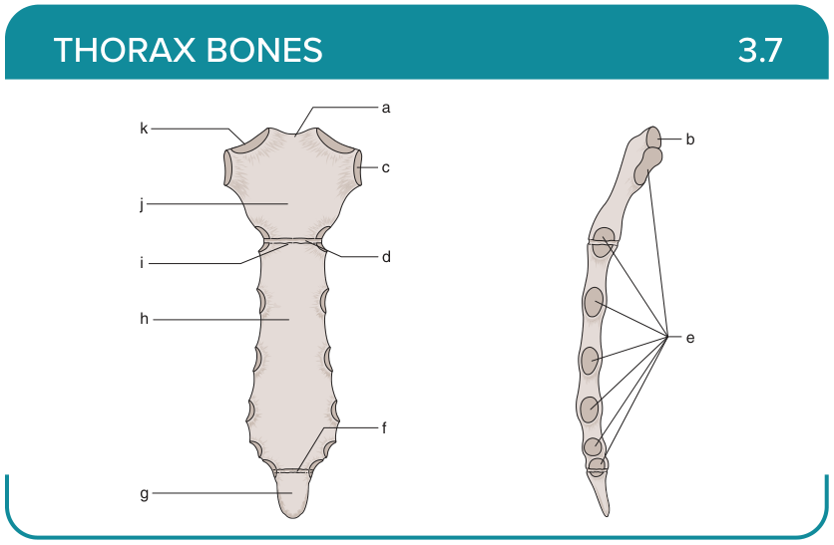
Title: Sternum (Anterior and Lateral View)
Activity Interaction: Drag and drop
Back-of-Card Content:
a. Jugular notch
b. Facet for articulation with the clavicle
c. Facet for articulation with the clavicle
d. Manubriosternal joint
e. Facets for articulation with ribs
f. Xiphisternal joint
g. Xiphoid process
h. Body of the sternum
i. Sternal angle
j. Manubrium
k. Clavicular notch

Card ID: 3.8
Image file: L1344_760083
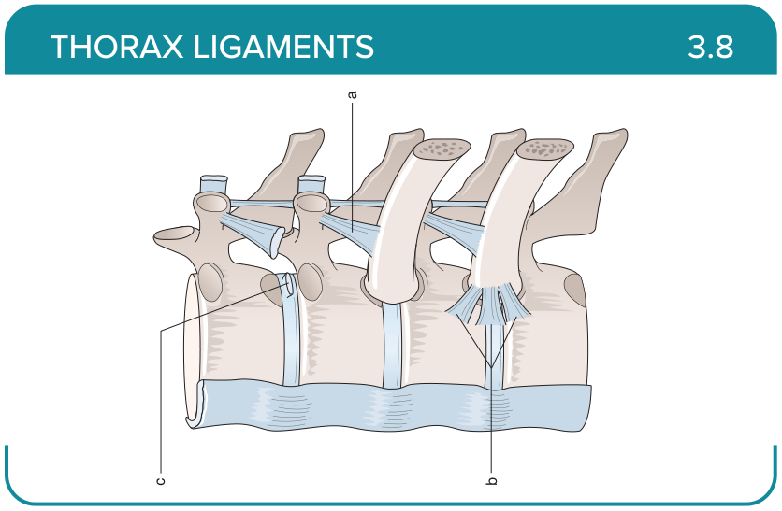
Title: Thorax
Activity Interaction: fill-in-the-blank
Back-of-Card Content:
a. Radiate ligament: attaches ribs to thoracic vertebrae and intervertebral discs
b. Intra-articular ligament of the head of the rib: attaches intervertebral disc to the ridge in between the two facets of the head of the rib
c. Costotransverse ligament: protects nerves within the intervertebral foramen, provides stability to the joint, and restricts excessive movements of the ribs at the transverse joint during inhalation

Card ID: 3.9
Image file: L1344_760084
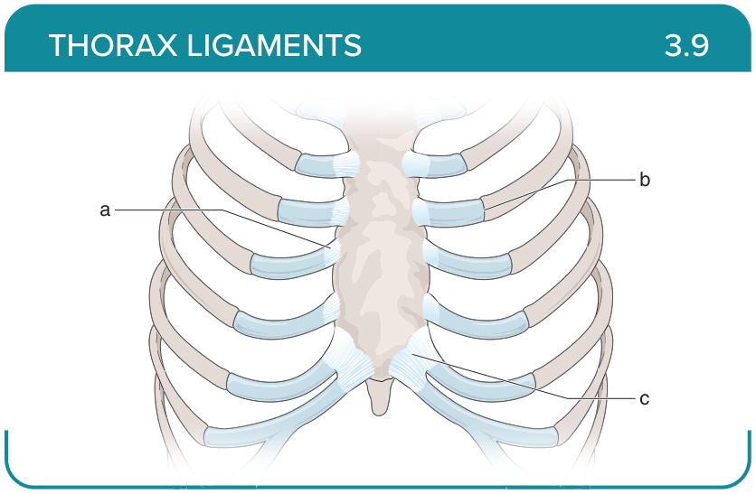
Title: Thorax
Activity Interaction: fill-in-the-blank
Back-of-Card Content:
a. Sternocostal ligaments (radiate + intra-articular): restricts movement at the sternocostal joint
b. Costochondral ligaments: reinforces costochondral joint
c. Costoxiphoid ligaments: reinforces joints

Card ID: 3.10
Image file: L1344_760085
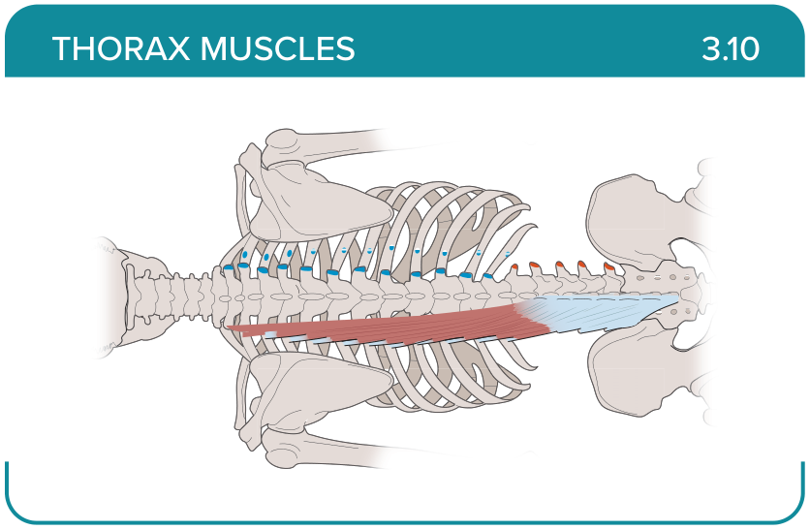
Title: Longissimus thoracic
Activity Interaction: Select all that apply
Back-of-Card Content:
Proximal insertion:
- *lumbar aponeurosis
- *medial part of the sacropelvic surface
- *posterior sacroiliac ligament
- *spinous and transverse process of L1-L5

Distal insertion:
- *accessory and transverse processes of T12-L5
- *angles of ribs 7 to 12
- ilium

Innervation:
- *lateral branch of the posterior rami of the spinal nerves
- dorsal rami of the thoracic and lumbar spinal nerves (T7-L3)
- posterior rami of the spinal nerves

Action:
- *bilateral contraction—spine extension
- *unilateral contraction—ipsilateral side bending of the spine
- assists in expiration
- unilateral contraction—contralateral side bending of the spine

Card ID: 3.11
Image file: L1344_760086
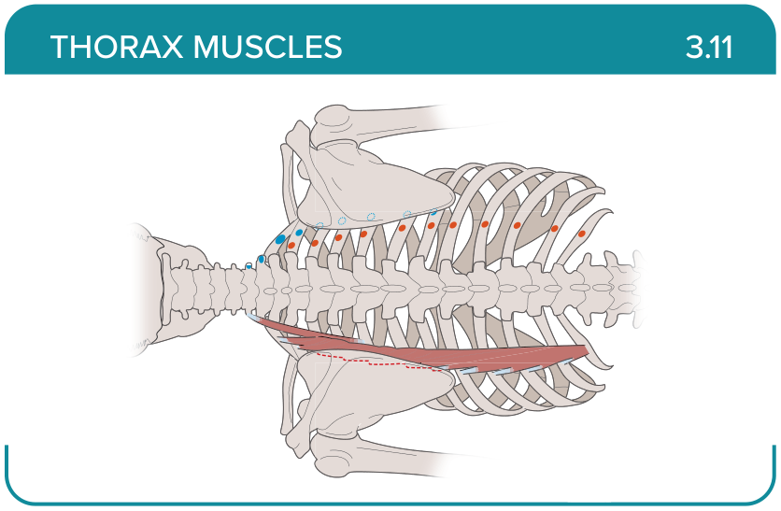
Title: Iliocostalis thoracic
Activity Interaction: Select all that apply
Back-of-Card Content:
Proximal insertion:
- *spinous process of the lumbar vertebrae
- *posterior part of the medial lip of the iliac crest
- *supraspinous ligament
- *lateral crest of the sacrum
Distal insertion:
- *nuchal ligament
- *ribs 3 to 12
- *thoracic and lumbar vertebrae

Innervation:
- *dorsal rami of the thoracic and lumbar spinal nerves (T7-L3)
- posterior rami of the spinal nerves
- lateral branch of the posterior rami of the spinal nerves
Action:
- *bilateral contraction—spine extension
- *unilateral contraction—lateral flexion of the spine
- *assists in expiration
- assists in inhalation

Card ID: 3.12
Image file: L1344_760087
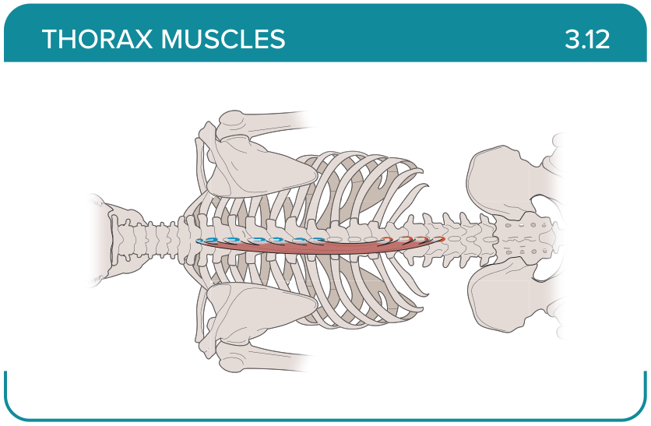
Title: Semispinalis
Activity Interaction: Select all that apply
Back-of-Card Content:
Proximal insertion:
- *thoracic and lumbar vertebrae
- *sacrum
- *posterior aspect of the iliac crest
- *sacroiliac and supraspinous ligament
Distal insertion:
- *spinous process of C2, T1-T8
- *occiput of the skull
- ribs 3 to 12
- ilium

Innervation:
- *posterior rami of the spinal nerves
- dorsal rami of the thoracic and lumbar spinal nerves (T7-L3)
- lateral branch of the posterior rami of the spinal nerves

Action:
- *unilateral flexion of the vertebral column
- *bilateral extension of the vertebral column
- assists in expiration
- assists in inhalation

Card ID: 3.13
Image file: L1344_760088
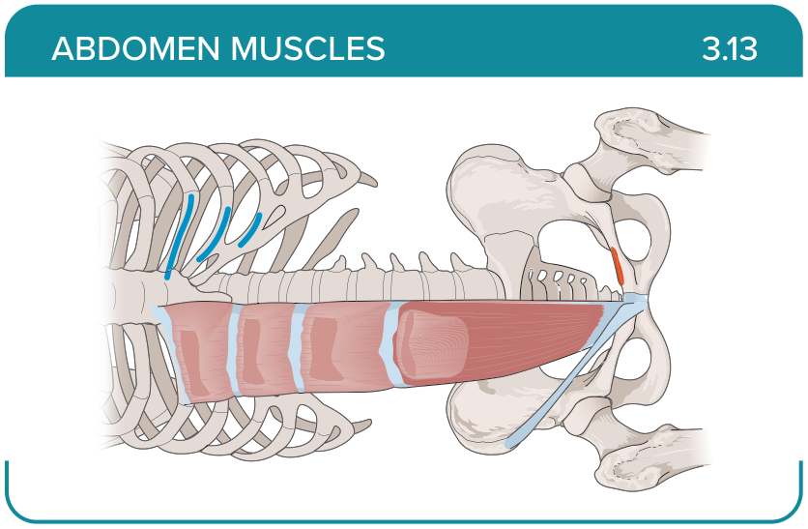
Title: Abdomen: Rectus abdominis
Activity Interaction: Select all that apply
Back-of-Card Content:
Proximal insertion:
- *pubis
- lumbar aponeurosis
- medial part of the sacropelvic surface
- posterior sacroiliac ligament

Distal insertion:
- *sternum
- *ribs 5 to 7
- accessory and transverse processes of T12-L5

Innervation:
- *anterior rami of the thoracic spinal nerves (T6-T12)
- lateral branch of the posterior rami of the spinal nerves
- dorsal rami of the thoracic and lumbar spinal nerves (T7-L3)
- posterior rami of the spinal nerves

Action:
- *trunk flexion
- *abdominal compression
- *core stability
- trunk rotation

Card ID: 3.14
Image file: L1344_760089
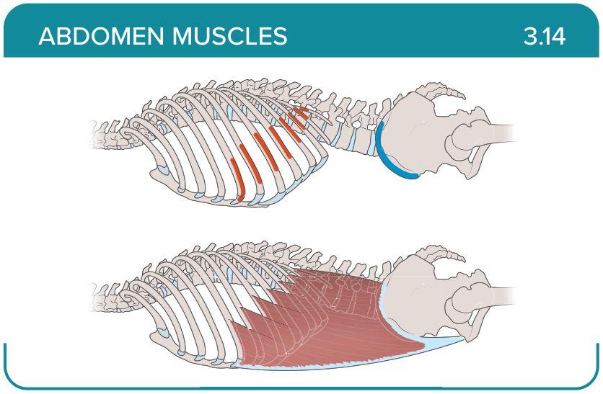
Title: Abdomen: External oblique
Activity Interaction: Select all that apply
Back-of-Card Content:
Proximal insertion:
- *ribs 5 to 12
- *ilium
- spinous and transverse process of L1-L5

Distal insertion:
- *ribs 7 to 10
- *linea alba
- *ilium
- transverse process of lumbar vertebrae
Innervation:
- *intercostal nerves (T7-11)
- *subcostal nerve (T12)
- *iliohypogastric nerve (L1)
- *ilioinguinal nerve (L1)
Action:
- *trunk lateral flexion
- *contralateral rotation
- *trunk flexion
- ipsilateral rotation

Card ID: 3.15
Image file: L1344_760090
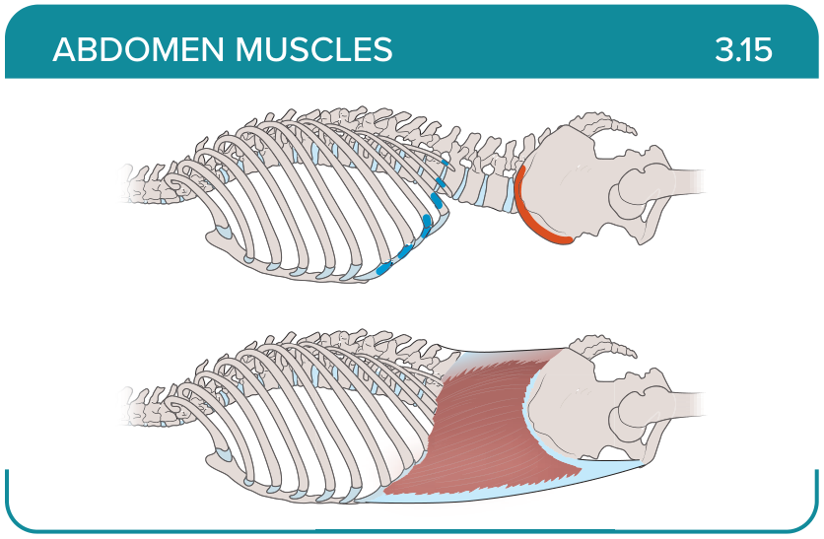
Title: Abdomen: Internal oblique
Activity Interaction: Select all that apply
Back-of-Card Content:
Proximal insertion:
- *thoracolumbar fascia
- *anterior two thirds of the iliac crest
- *lateral two thirds of the inguinal ligament
- posterior sacroiliac ligament

Distal insertion:
- *inferior borders of ribs 10 to 12
- *linea alba
- *pubic crest
- ilium

Innervation:
- *intercostal nerves (T7-11)
- *subcostal nerve (T12)
- *iliohypogastric (L1)
- *ilioinguinal nerve (L1)
Action:
- *trunk flexion
- *compression of intra-abdominal viscera
- *ipsilateral flexion and rotation
- contralateral flexion and rotation

Card ID: 3.16
Image file: L1344_760091
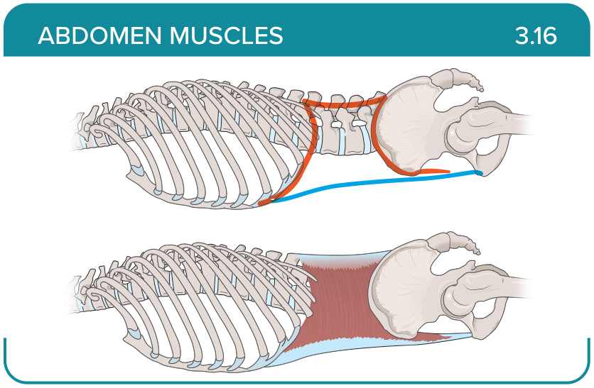
Title: Abdomen: Transverse abdominis
Activity Interaction: Select all that apply
Back-of-Card Content:
Proximal insertion:
- *ilium
- *ribs 5 to 10
- lumbar aponeurosis
- transverse process of lumbar vertebrae

Distal insertion:
- *sternum
- *linea alba
- *pubis
- transverse process of lumbar vertebrae

Innervation:
- *intercostal nerves (T7-11)
- *subcostal nerve (T12)
- *iliohypogastric (L1)
- *ilioinguinal nerve (L1)

Action:
- *squeezes the abdomen during forced exhalation
- *defecation, urination, and childbirth
- contralateral flexion and rotation

Card ID: 3.17
Image file: L1344_760092
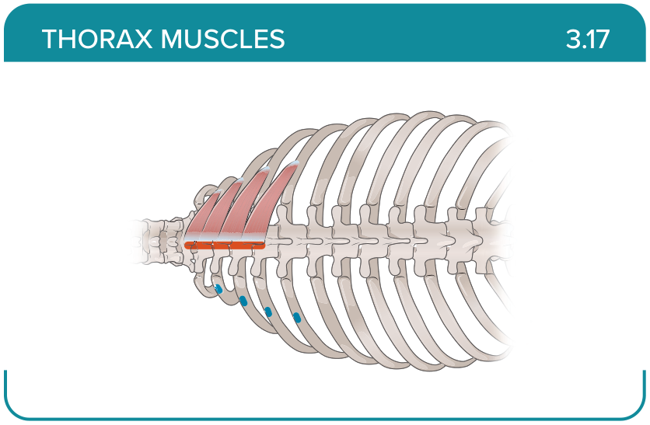
Title: Serratus posterior superior
Activity Interaction: Select all that apply
Back-of-Card Content:
Proximal insertion:
- *nuchal ligament
- *spinous processes of C7-T3
- spinous processes of T11-L2 vertebrae
Distal insertion:
- *external surfaces of the second to fifth ribs
- external surfaces of ribs 9 to 12
- lateral border of scapula

Innervation:
- *anterior rami of nerves T2-T5
- anterior rami of nerves T9 to T12
- adjacent intercostal nerves
Action:
- *elevates the ribs at the costovertebral joints
- depresses the ribs at the costovertebral joints
- contralateral flexion and rotation
- ipsilateral flexion and rotation

Card ID: 3.18
Image file: L1344_760093
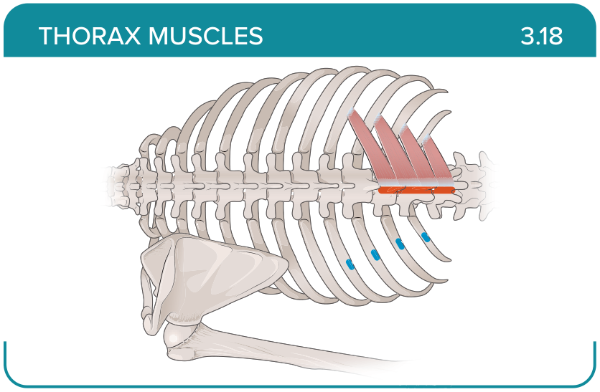
Title: Serratus posterior inferior
Activity Interaction: Select all that apply
Back-of-Card Content:
Proximal insertion:
- nuchal ligament
- spinous processes of C7-T3
- *spinous processes of T11-L2 vertebrae

Distal insertion:
- *external surfaces of ribs 9 to 12
- lateral border of scapula
- external surfaces of the second to fifth ribs

Innervation:
- *anterior rami of nerves T9 to T12
- adjacent intercostal nerves
- anterior rami of nerves T2 to T5

Action:
- *depresses the ribs at the costovertebral joints
- elevates the ribs at the costovertebral joints
- contralateral flexion and rotation
- ipsilateral flexion and rotation

Card ID: 3.19
Image file: L1344_760094
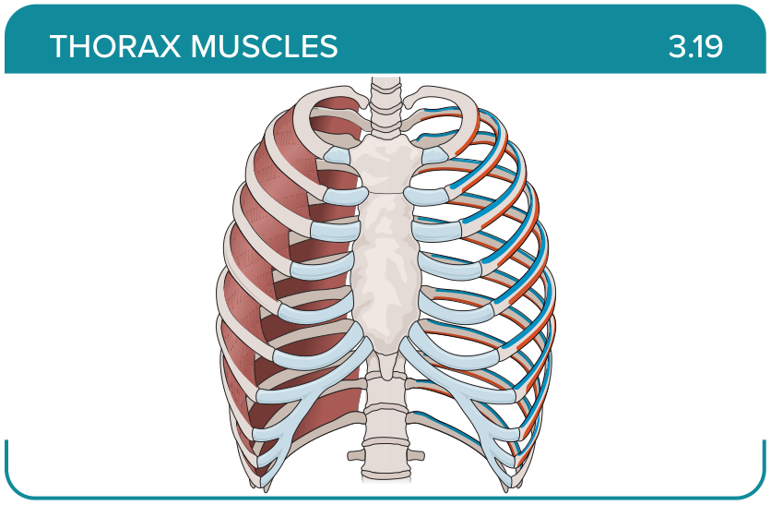
Title: External intercostals
Activity Interaction: Select all that apply
Back-of-Card Content:
Proximal insertion:
- *inferior borders of ribs 1 to 11 and their adjacent costal cartilages
- costal grooves of the ribs
- sternum
Distal insertion:
- *superior borders of ribs and costal cartilages immediately below the origin sites
- inferior borders of ribs and costal cartilages immediately below the origin sites
- external surfaces of the second to fifth ribs
Innervation:
- *adjacent intercostal nerves
- posterior rami of the spinal nerves
- dorsal rami of the thoracic and lumbar spinal nerves

Action:
- *elevates the ribs at the costovertebral joints
- *provides support of the intercostal spaces
- depresses the ribs at the costovertebral joints

Card ID: 3.20
Image file: L1344_760095
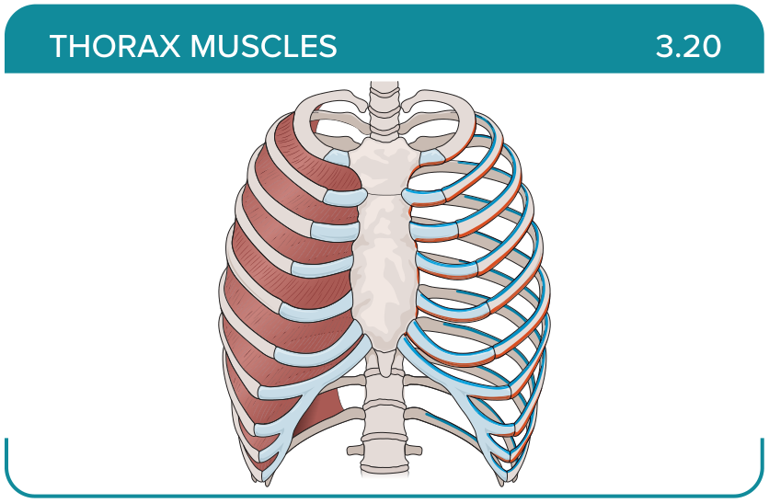
Title: Internal intercostals
Activity Interaction: Select all that apply
Back-of-Card Content:
Proximal insertion:
- *inferior borders of ribs 1 to 11 and their adjacent costal cartilages
- costal grooves of the ribs
- external surfaces of the second to fifth ribs

Distal insertion:
- *superior borders of ribs and costal cartilages immediately below the origin sites
- inferior borders of ribs and costal cartilages immediately below the origin sites
Innervation:
- *adjacent intercostal nerves
- posterior rami of the spinal nerves
- dorsal rami of the thoracic and lumbar spinal nerves
Action:
- *depresses the ribs at the costovertebral joints
- *provides structural support to the intercostal spaces
- contralateral flexion and rotation
- ipsilateral flexion and rotation

Card ID: 3.21
Image file: L1344_760096
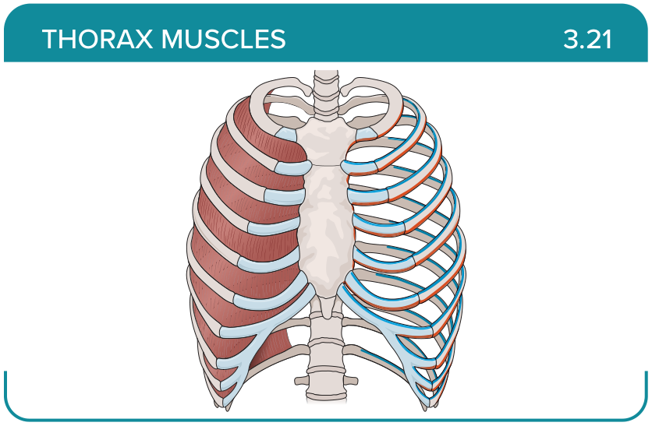
Title: Innermost intercostals
Activity Interaction: Select all that apply
Back-of-Card Content:
Proximal insertion:
- *costal grooves of the ribs
- inferior borders of ribs 1 to 11 and their adjacent costal cartilages
- external surfaces of the fifth to twelfth ribs
Distal insertion:
- *superior border of the immediate rib below
- inferior borders of ribs 1 to 11 and their adjacent costal cartilages
Innervation:
- *intercostal nerves
- posterior rami of the spinal nerves
- dorsal rami of the thoracic and lumbar spinal nerves
Action:
- *depresses the ribs during forced expiration
- *supports the intercostal spaces and the thoracic cage
- assists in trunk rotation

Card ID: 3.22
Image file: L1344_760097
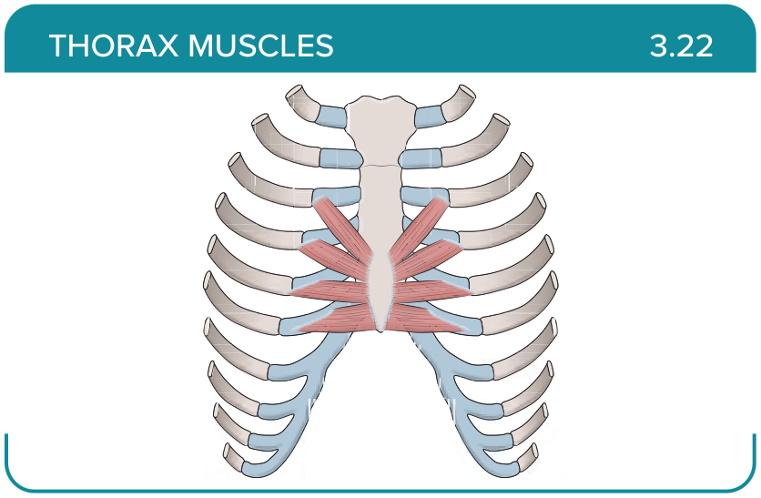
Title: Transversus thoracic
Activity Interaction: Select all that apply
Back-of-Card Content:
Proximal insertion:
- *posterolateral aspects of the body and xyphoid process of the sternum
- inferior borders of ribs 1 to 11 and their adjacent costal cartilages
- inferior border of the clavicle
Distal insertion:
- *internal surfaces of costal cartilages two to six and costal ends of the adjacent ribs
- superior borders of ribs and costal cartilages immediately below the origin sites
- anterior surface of the manubrium of the sternum

Innervation:
- *adjacent intercostal nerves
- posterior rami of the spinal nerves
- dorsal rami of the thoracic and lumbar spinal nerves
Action:
- *depresses the ribs and their costal cartilages
- elevates the ribs at the costovertebral joints
- assists with trunk flexion

Card ID: 3.23
Image file: L1344_760098
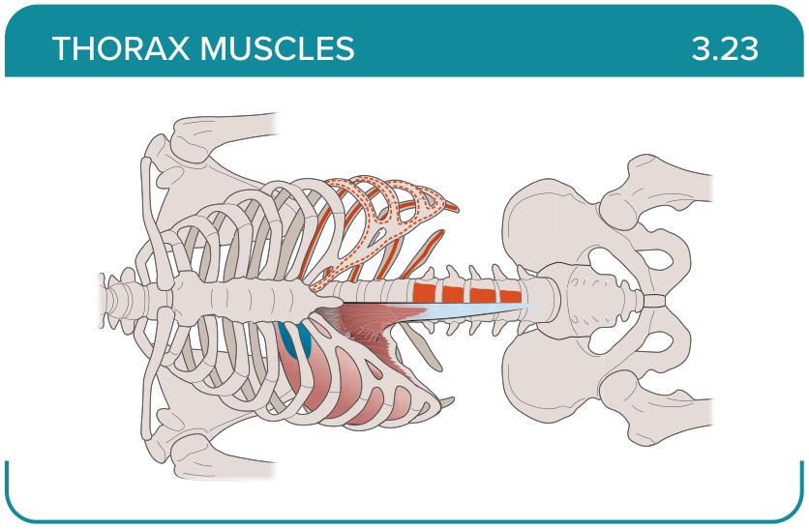
Title: Diaphragm
Activity Interaction: Select all that apply
Back-of-Card Content:
Proximal insertion:
- *xyphoid process
- *internal surfaces of costal cartilages 7 to 12 and adjacent ribs
- *medial and lateral arcuate ligaments
- *vertebrae L1-L3
Distal insertion:
- *central tendon
- thoracolumbar fascia
Innervation:
- *phrenic nerves (C3-C5)
- vagus nerve
- posterior rami of the spinal nerves

Action:
- *serves as the primary muscle of inspiration
- assists in trunk flexion

